Superstore Sales and Profit Performance Analysis Report
1. Introduction
This report analyzes sales and profit performance across categories, sub-categories, time periods, and regions. The objective is to identify underperforming areas, evaluate trends, and highlight factors influencing business performance.
2. Underperforming Categories and Sub-Categories
2.1 Category Performance
Among the three product categories, Office Supplies recorded the lowest total sales ($719,047.03), making it the least performing category, although the gap between categories is relatively small.
2.2 Sub-Category Performance
Several sub-categories show clear underperformance based on significantly low sales figures:
- Fasteners ($3,024.28)
- Labels ($12,486.31)
- Envelopes ($16,476.40)
- Art ($27,118.79)
These sub-categories contribute minimally to total revenue, indicating low demand, weak market appeal, or insufficient promotional efforts.

3. Sales and Profit Trends Over Time
3.1 Sales Trend Analysis
Sales performance demonstrates a seasonal pattern:
- Low sales observed in January and February
- Gradual increase from March through August
- Significant surge in September to December (Q4)
- Peak sales recorded in November ($352,461.07) and December ($325,293.50)
3.2 Profit Trend Analysis
Profit trends closely follow sales patterns:
- Lowest profit recorded in January ($9,134.45)
- Steady growth throughout the year
- Peak profit achieved in December ($43,369.19)
3.3 Key Observation
There is a strong positive relationship between sales and profit, and overall performance is heavily driven by Q4 seasonal demand.

4. Factors Contributing to Decline
Several factors may explain the observed decline in certain periods and segments:
4.1 Seasonal Demand Fluctuation
- Reduced consumer spending after the holiday season leads to low performance in early months (Jan–Feb).
4.2 Weak Product Performance
- Underperforming sub-categories may suffer from:
  - Low customer demand
  - Poor product positioning
  - Limited marketing exposure
4.3 Limited Off-Season Promotions
- Sales data suggests a reliance on peak-season promotions, with insufficient strategies to boost revenue during slower months.
4.4 Regional Disparities
- Uneven sales distribution across regions impacts overall performance consistency.
4.5 Competitive and Pricing Pressures
- External market competition or pricing inefficiencies may also contribute to reduced sales in certain categories or periods.
5. Regional Performance Comparison
5.1 Sales by Region
- West: $725,457.82
- East: $678,781.24
- Central: $501,239.89
- South: $391,721.91

5.2 Key Finding
The South region recorded the lowest sales, indicating it is the most underperforming region.
5.3 Interpretation
The weak performance in the South may be due to:
- Lower market penetration
- Ineffective marketing strategies
- Limited customer demand or distribution challenges

6. Conclusion
The analysis reveals that while the business is overall profitable, performance is uneven across products, time periods, and regions. Growth is primarily driven by a few high-performing categories and strong Q4 sales, while several sub-categories and regions lag behind.
To improve overall performance, the business should focus on:
- Strengthening underperforming product lines
- Addressing seasonal sales gaps
- Expanding growth efforts in weaker regions, particularly the South

VISUAL IN POWER BI

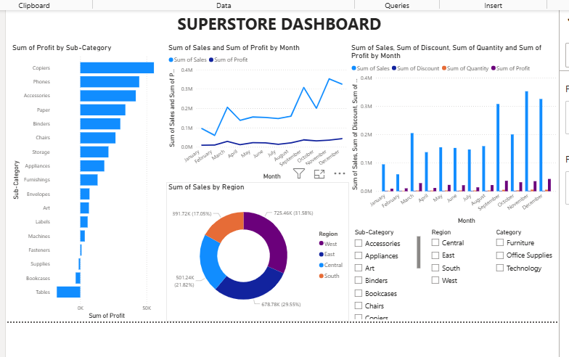
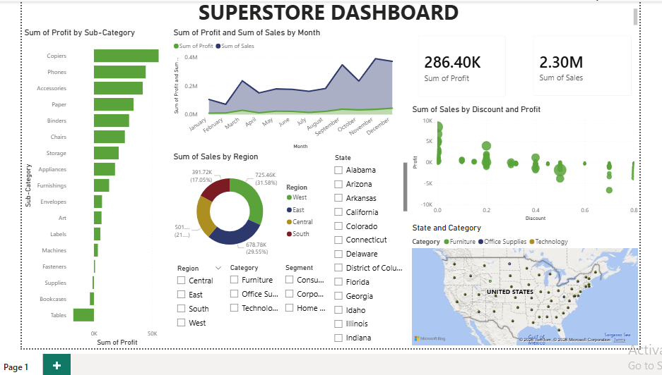
VISUAL IN TABLEAU
